Highfields
20 Day Spring Saving

Choose your favourite caravan and perfect plot now and receive the following absolutely Free (saving over £2,500)!

* Hurry Offer Ends 31st March *

£500 Off Any Caravan Holiday Home!

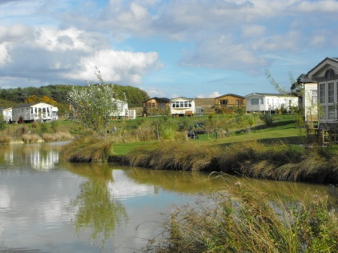
Free - 2013/2014 Pitch Fee

£500 of Accessories - Free!

Free - 32" LCD TV

* AND FREE 47kg GAS BOTTLE *

** Offer Ends 5pm 31st March **

